## **How to use the Gitcoin Passport Stamp Scoring and Exploration App**

**Introduction**

Passport is a decentralized identifier. Users collect “stamps” from different authenticators around web2 and web3, such as Bright ID and Proof of Humanity. Stamps are verifiable credentials – by aggregating several of them in one place, Passport distributes trust across multiple entities. After integrating with Passport, instead of relying on a middleman to verify someone’s identity, dApps can verify it themselves with a customizable algorithm that weights different stamps according to their preferences, essentially allowing communities to create a customizable visa with their participation requirements.

The passport stamp scoring and exploration app is a web based tool that allows you to view adoption statistics related to the current set of Gitcoin Passport stamps, compare existing scoring methods by their sybil detection accuracy, and even create your customized score from directly within the app. The application comprises a total number of 54 stamps that can be used for different computations.

The homepage of this application comprises five tabs, each of which will be discussed in detail in the subsequent sections.



Figure 1: Gitcoin passport and stamp scoring application homepage

**Stamps on the wheel**

The passport stamp and scoring app (PSSA) has on its homepage, a stamp statistic tab. In this tab, users can get information and statistics on various stamps. 



Figure 2: Stamp Stats tab

Click the select stamp drop down menu at the bottom left of the homepage, select the stamp you want to get information and/or statistics. Prevalent amongst these statistics are:

1. Stamp Holder count: This displays the number of gitcoin users who holds the stamp
2. Percentage of passports with stamps: This shows the percentage of gitcoin users that have the selected stamp on their passport.
3. Thor label count: This is the number of non-sybil gitcoin users that have the selected stamp on their passport.
4. Loki label count: As you may have guessed, this is the number of sybil gitcoin users that have the selected stamp on their passport.
5. The other part of the stamp stats shows the computation for the following:
   1. Regularized logistic regression
   2. Ordinary logistic regression
   3. Cost of Forgery (kish weight)
   4. FDD regen weight

**Stamp comparison**

The second tab of the passport stamp scoring and exploration application is where users can run comparisons on different stamps. These comparisons can be carried out on two or more (up to five) stamps. The following are compared across all selected stamps:

1. Number of stamp holders
2. Percentage of passports with stamps
3. Stamp category
4. Thor label count
5. Loki label count
6. Regularized Logistic regression coefficient
7. Ordinary Logistic regression coefficient
8. Cost of forgery (COF kish weight)
9. FDD regen weight



Figure 3: Stamp comparison tab

**Create a scoring method**

In this section of the application, users can add a custom scoring method. This section allows users to input weights of each stamps, to see the following computation based on the weights given by the user:

1. Accuracy:
2. Cutoff Default
3. Predicted Thor: number of Gitcoin users that are predicted not to be sybil based on the selected weights, type and the prefill.
4. Predicted Loki: This is the inverse of the predicted thor. This shows the predicted number of Gitcoin users that are sybil based on the selected weights, type and the prefill.

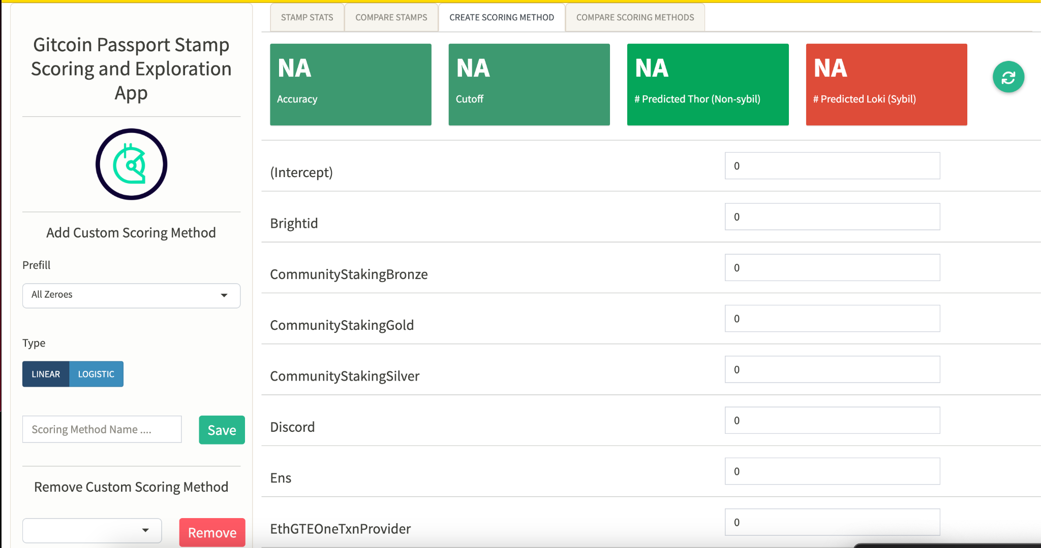

Figure 4: Create Scoring method tab

**How to create a scoring method:**

Step 1: Select a prefill. Here you can select any of the pre-existing scoring methods, or choose all panes to be either “All zeros” (which defaults all panes to 0) or “All ones” (which sets all panes to a value of 1).

Step 2: Select a scoring type. The two scoring types that exists are:

* Linear regression: This produces a continuous output based on the weights on the based the weighted stamps, to find the best fitted line.
* Logistic regression: This takes the prediction of the linear regression further by fitting the line values to the sigmoid curve.

Step 3: Scroll through the stamps and fill the stamp panes with weights.

Step 4: Click the “refresh” button beside the predictions to generate the output of the computation based on the weighted stamps.

Step 5: Name this scoring method and save it accordingly.

**Compare existing scoring methods**

In this section, different scoring methods can be compared. The Distribution tab is used to compare the distribution of non-sybil across different scoring methods, while the Stats tab shows different statistics based on the selected scoring methods. These two tabs are discussed further below.

* Distribution: This tab shows the distribution of predicted probabilities of being non-sybil (Thor) using the selected scoring methods. To do this, follow the steps below:
  + Step 1: Select the scoring methods you want to compare. Notably, if you have created a scoring method, you can compare your scoring method against pre-existnig (or other created) scoring methods, by selecting them. 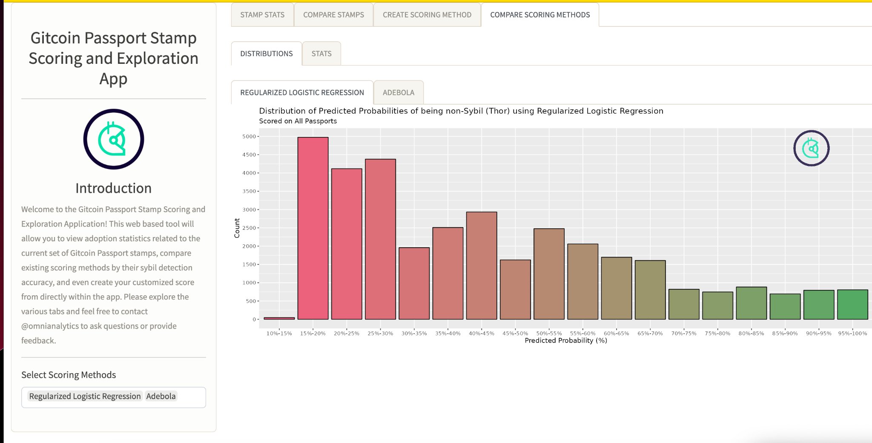
  + Step 2: This generates different tabs based on the selected scoring methods to be compared, click on each tab to see the distribution of each.
* Stats: This Tab shows the different statistical comparison of scoring methods selected for comparison such as model type, model accuracy, number of Thor and Loki, etc.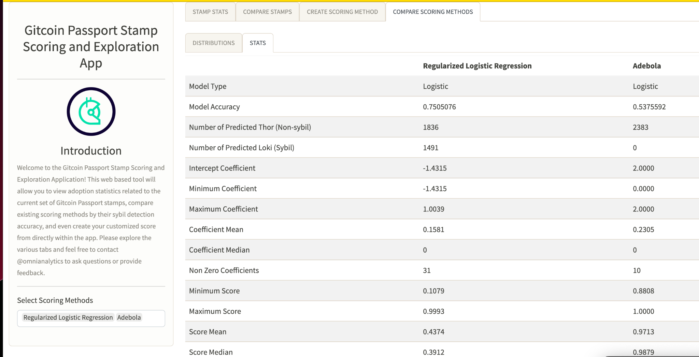

**Conclusion:**